Приход на склад обуви

Коробка с одним размером обуви
(00)011133355577799911(21)000box1

Коробка с одним размером обуви
(00)033355577799911133(21)000box2

Коробка с двумя размерами обуви
(00)055577799911133355(21)000box3

Товары

Кроссовки Клеверенс, 39
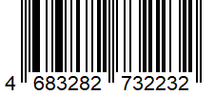
4683282732232

Кроссовки Клеверенс, 42
4683282736438

Кроссовки Клеверенс, 36
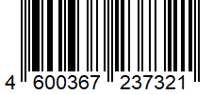
4600367237321

Марки

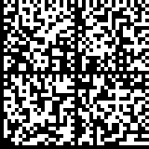
010468328273223221371120091000191ffd092MDEwNDM4MzI4MjczMjIzMTIxMzcxMTE5MTkxOTk2Nh0yNDA2NDAxHTkxZmZkMB05MjA4MDQyMDE54zExMTkzNw==

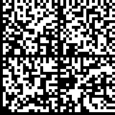
010468328273223221371120092000191ffd092MDEwNDM4MzI4MjczMjIzMTIxMzcxMTE5MTkxOTk2Nh0yNDA2NDAxHTkxZmZkMB05MjA4MDQyMDE54zExMTkzNw==

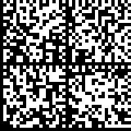
010468328273223221371120093000191ffd092MDEwNDM4MzI4MjczMjIzMTIxMzcxMTE5MTkxOTk2Nh0yNDA2NDAxHTkxZmZkMB05MjA4MDQyMDE54zExMTkzNw==

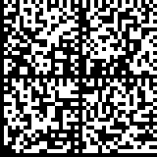
010468328273223221371120094000191ffd092MDEwNDM4MzI4MjczMjIzMTIxMzcxMTE5MTkxOTk2Nh0yNDA2NDAxHTkxZmZkMB05MjA4MDQyMDE54zExMTkzNw==

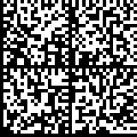
010468328273223221371120095000191ffd092MDEwNDM4MzI4MjczMjIzMTIxMzcxMTE5MTkxOTk2Nh0yNDA2NDAxHTkxZmZkMB05MjA4MDQyMDE54zExMTkzNw==

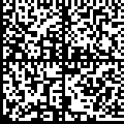
010468328273223221371120096000191ffd092MDEwNDM4MzI4MjczMjIzMTIxMzcxMTE5MTkxOTk2Nh0yNDA2NDAxHTkxZmZkMB05MjA4MDQyMDE54zExMTkzNw==

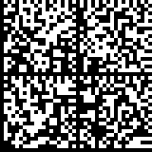
010468328273643821371120011000191ffd092MDEwNDM4MzI4MjczMjIzMTIxMzcxMTE5MTkxOTk2Nh0yNDA2NDAxHTkxZmZkMB05MjA4MDQyMDE54zExMTkzNw==

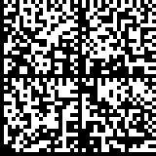
010468328273643821371120012000191ffd092MDEwNDM4MzI4MjczMjIzMTIxMzcxMTE5MTkxOTk2Nh0yNDA2NDAxHTkxZmZkMB05MjA4MDQyMDE54zExMTkzNw==

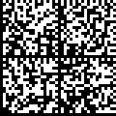
010468328273643821371120013000191ffd092MDEwNDM4MzI4MjczMjIzMTIxMzcxMTE5MTkxOTk2Nh0yNDA2NDAxHTkxZmZkMB05MjA4MDQyMDE54zExMTkzNw==

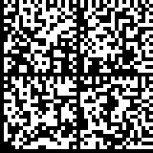
010468328273643821371120014000191ffd092MDEwNDM4MzI4MjczMjIzMTIxMzcxMTE5MTkxOTk2Nh0yNDA2NDAxHTkxZmZkMB05MjA4MDQyMDE54zExMTkzNw==

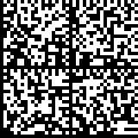
010468328273643821371120015000191ffd092MDEwNDM4MzI4MjczMjIzMTIxMzcxMTE5MTkxOTk2Nh0yNDA2NDAxHTkxZmZkMB05MjA4MDQyMDE54zExMTkzNw==

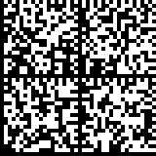
010468328273643821371120016000191ffd092MDEwNDM4MzI4MjczMjIzMTIxMzcxMTE5MTkxOTk2Nh0yNDA2NDAxHTkxZmZkMB05MjA4MDQyMDE54zExMTkzNw==

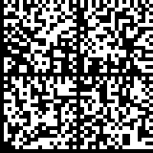
010460036723732121371120022000191ffd092MDEwNDM4MzI4MjczMjIzMTIxMzcxMTE5MTkxOTk2Nh0yNDA2NDAxHTkxZmZkMB05MjA4MDQyMDE54zExMTkzNw==

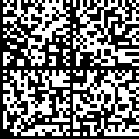
010460036723732121371123020000191ffd092MDEwNDM4MzI4MjczMjIzMTIxMzcxMTE5MTkxOTk2Nh0yNDA2NDAxHTkxZmZkMB05MjA4MDQyMDE54zExMTkzNw==

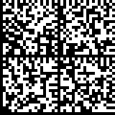
010460036723732121371120024000191ffd092MDEwNDM4MzI4MjczMjIzMTIxMzcxMTE5MTkxOTk2Nh0yNDA2NDAxHTkxZmZkMB05MjA4MDQyMDE54zExMTkzNw==
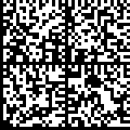
010468328273643821371120017000191ffd092MDEwNDM4MzI4MjczMjIzMTIxMzcxMTE5MTkxOTk2Nh0yNDA2NDAxHTkxZmZkMB05MjA4MDQyMDE54zExMTkzNw==

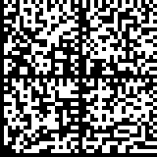
010468328273643821371120018000191ffd092MDEwNDM4MzI4MjczMjIzMTIxMzcxMTE5MTkxOTk2Nh0yNDA2NDAxHTkxZmZkMB05MjA4MDQyMDE54zExMTkzNw==

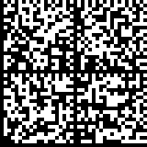
010468328273643821371120019000191ffd092MDEwNDM4MzI4MjczMjIzMTIxMzcxMTE5MTkxOTk2Nh0yNDA2NDAxHTkxZmZkMB05MjA4MDQyMDE54zExMTkzNw==

Подбор заказа

Коробки
(00)066688800022244466(21)000shs1

(00)088800022244466688(21)000shs2

(00)088800022244466688(21)000shs3

Марки

010468328273223221371119191033091ffd092MDEwNDM4MzI4MjczMjIzMTIxMzcxMTE5MTkxOTk2Nh0yNDA2NDAxHTkxZmZkMB05MjA4MDQyMDE5XzExMTkzNK==

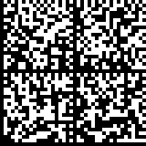
010468328273223221371119191033191ffd092MDEwNDM4MzI4MjczMjIzMTIxMzcxMTE5MTkxOTk2Nh0yNDA2NDAxHTkxZmZkMB05MjA4MDQyMDE5XzExMTkzNZ==

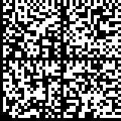
010468328273223221371119191033291ffd092MDEwNDM4MzI4MjczMjIzMTIxMzcxMTE5MTkxOTk2Nh0yNDA2NDAxHTkxZmZkMB05MjA4MDQyMDE5XzExMTkzNX==

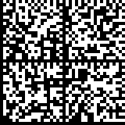
010468328273223221371119191033391ffd092MDEwNDM4MzI4MjczMjIzMTIxMzcxMTE5MTkxOTk2Nh0yNDA2NDAxHTkxZmZkMB05MjA4MDQyMDE5XzExMTkzAW==

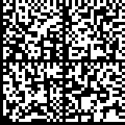
010468328273223221371119191033491ffd092MDEwNDM4MzI4MjczMjIzMTIxMzcxMTE5MTkxOTk2Nh0yNDA2NDAxHTkxZmZkMB05MjA4MDQyMDE5XzExMTkzBI==

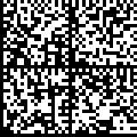
010468328273223221371119191033591ffd092MDEwNDM4MzI4MjczMjIzMTIxMzcxMTE5MTkxOTk2Nh0yNDA2NDAxHTkxZmZkMB05MjA4MDQyMDE5XzExMTkzCF==

010468328273223221371119191033691ffd092MDEwNDM4MzI4MjczMjIzMTIxMzcxMTE5MTkxOTk2Nh0yNDA2NDAxHTkxZmZkMB05MjA4MDQyMDE5XzExMTkzDa==

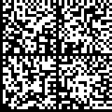
010468328273223221371119191033791ffd092MDEwNDM4MzI4MjczMjIzMTIxMzcxMTE5MTkxOTk2Nh0yNDA2NDAxHTkxZmZkMB05MjA4MDQyMDE5XzExMTkzNa==

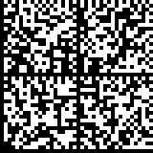
010468328273223221371119191033891ffd092MDEwNDM4MzI4MjczMjIzMTIxMzcxMTE5MTkxOTk2Nh0yNDA2NDAxHTkxZmZkMB05MjA4MDQyMDE5XzExMTkzNb==

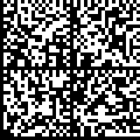
010468328273223221371119191033991ffd092MDEwNDM4MzI4MjczMjIzMTIxMzcxMTE5MTkxOTk2Nh0yNDA2NDAxHTkxZmZkMB05MjA4MDQyMDE5XzExMTkzNt==

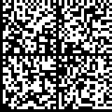
010468328273643821371119191031191ffd092MDEwNDM4MzI4MjczMjIzMTIxMzcxMTE5MTkxOTk2Nh0yNDA2NDAxHTkxZmZkMB05MjA4MDQyMDE5XzExMTkzNj==

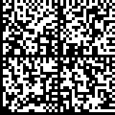
010468328273643821371119191032191ffd092MDEwNDM4MzI4MjczMjIzMTIxMzcxMTE5MTkxOTk2Nh0yNDA2NDAxHTkxZmZkMB05MjA4MDQyMDE5XzExMTkzNq==

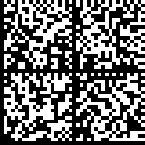
010468328273643821371119191033191ffd092MDEwNDM4MzI4MjczMjIzMTIxMzcxMTE5MTkxOTk2Nh0yNDA2NDAxHTkxZmZkMB05MjA4MDQyMDE5XzExMTkzNv==

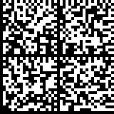
010468328273643821371119191034191ffd092MDEwNDM4MzI4MjczMjIzMTIxMzcxMTE5MTkxOTk2Nh0yNDA2NDAxHTkxZmZkMB05MjA4MDQyMDE5XzExMTkzVw==

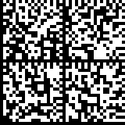
010468328273643821371119191035191ffd092MDEwNDM4MzI4MjczMjIzMTIxMzcxMTE5MTkxOTk2Nh0yNDA2NDAxHTkxZmZkMB05MjA4MDQyMDE5XzExMTkAaw==

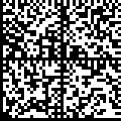
010460036723732121371119191036191ffd092MDEwNDM4MzI4MjczMjIzMTIxMzcxMTE5MTkxOTk2Nh0yNDA2NDAxHTkxZmZkMB05MjA4MDQyMDE5XzExMTkqQw==

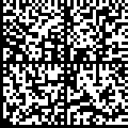
010460036723732121371119191037191ffd092MDEwNDM4MzI4MjczMjIzMTIxMzcxMTE5MTkxOTk2Nh0yNDA2NDAxHTkxZmZkMB05MjA4MDQyMDE5XzExMTkWNn==

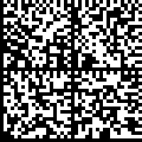
010460036723732121371119191038191ffd092MDEwNDM4MzI4MjczMjIzMTIxMzcxMTE5MTkxOTk2Nh0yNDA2NDAxHTkxZmZkMB05MjA4MDQyMDE5XzExMTkQFb==

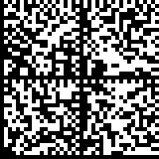
010460036723732121371119191044191ffd092MDEwNDM4MzI4MjczMjIzMTIxMzcxMTE5MTkxOTk2Nh0yNDA2NDAxHTkxZmZkMB05MjA4MDQyMDE5XzExMTkGWz==

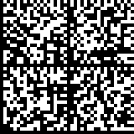
010460036723732121371119191045191ffd092MDEwNDM4MzI4MjczMjIzMTIxMzcxMTE5MTkxOTk2Nh0yNDA2NDAxHTkxZmZkMB05MjA4MDQyMDE5XzExMTknNA==

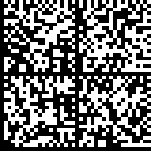
010460036723732121371119191046291ffd092MDEwNDM4MzI4MjczMjIzMTIxMzcxMTE5MTkxOTk2Nh0yNDA2NDAxHTkxZmZkMB05MjA4MDQyMDE5XzExMTkhNB==

010460036723732121371119191047291ffd092MDEwNDM4MzI4MjczMjIzMTIxMzcxMTE5MTkxOTk2Nh0yNDA2NDAxHTkxZmZkMB05MjA4MDQyMDE5XzExMTkvNA==

*Примечание – для тестирования работы с КМ (Марками) при помощи нашего приложения для тестирования и разработки WinClient Mobile SMARTS на ПК, необходимо в строку КМ вставить символы (GS) перед ai 91 и перед ai 92. Для этого рекомендуем использовать программу Notepad++, в которой они видны и их можно оттуда скопировать для вставки в WinClient.
